Sensor Model for Traffic Management
We consider all the sensors are deployed on the roadbed. Most of the sensors are in ‘sleep’ mode in most of the time. During ‘sleep’ mode, sensors will not do any data collection but will have their radio transceivers turned on so that they could wake up. Only a few guard sensors will be awaken all the time.

Problem Description
There are 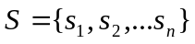 sensors and 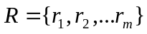 roads in the system where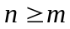. Each sensorbelongs to a road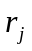and their relationship can be uniquely expressed as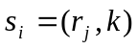where k is defined as the distance between the beginning of the road and the sensor.
Each sensor has two modes, sleep or working: 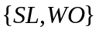
Most of the sensors are in sleep mode during most of the time. Only a small set of sensors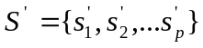are in working mode all the time (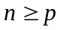).

Now, letbe a certain sensor in our model. Then sensorhas a predefined set of sensors 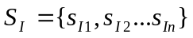(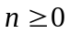) which could possibly wakeup. Sensoralso has a set of predefined sensors 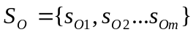(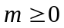) which will be possibly waken by. For any sensor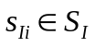, there exists certain rule expressed as:
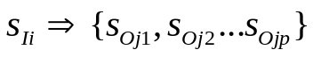
This rule defines that onceis waked up by 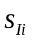and after certain event happens, sensorwill wake up all the sensors in 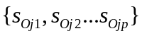
As an example illustrated with the following diagram:
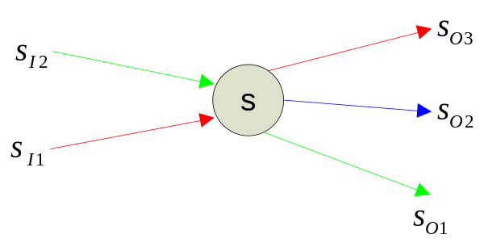
In this case, we have
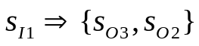and
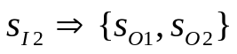

Objective
The objective of our system is that by exploiting the unguided nature of wireless communication, when a sensor node receive a wake-up command and begin to send wake-up commands to the downstream nodes, it can send as few messages as possible. Meanwhile, the messages should be sent as reliable as possible.

Application Scenarios
We can apply this model to different kinds of application scenarios in traffic management system.

